姓名： 班级： 学号：
人教版小学英语二年级上册期中复习题（B卷）

题号 | 一 | 二 | 三 | 四 | 五 | 六 | 总分
分数
- 看图读句子，选词填空
girl woman man boy

- My father is a ___.
- This is my mother.She is a ___.
- She’s my sister.She’s a ___.
- He’s my brother.He’s a ___.
- This is my father.He is a ___.
- 匹配正确的句子和图片
（）1. A.She is my classmate.B.He is my friend.
（）2. A.Who’s he?B.Who’s she?
（）3. A.Her name is Candy.B.He is a boy.
（）4.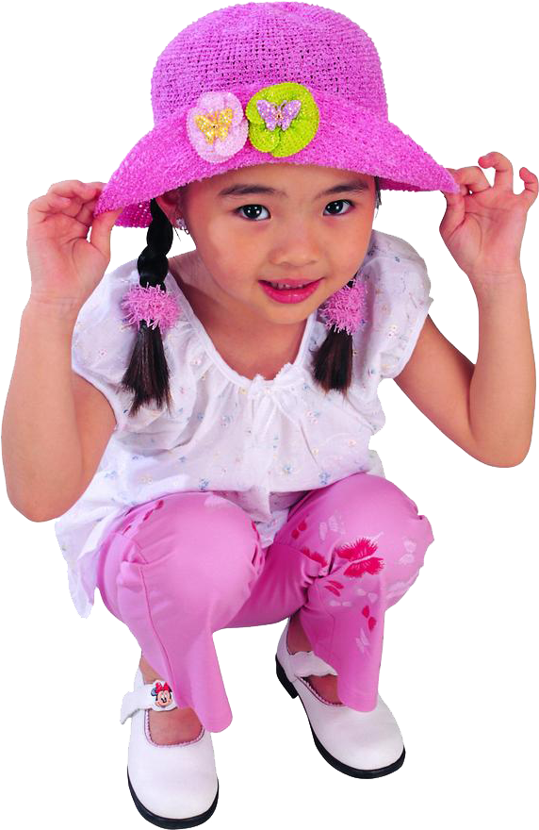 A.She is a girl.B.His name is Lulu.
（）5.My friend is tall and thin.She is a girl. A.
（）6.He is my father.He is handsome. B.
（）7.She is a woman.She is short. C.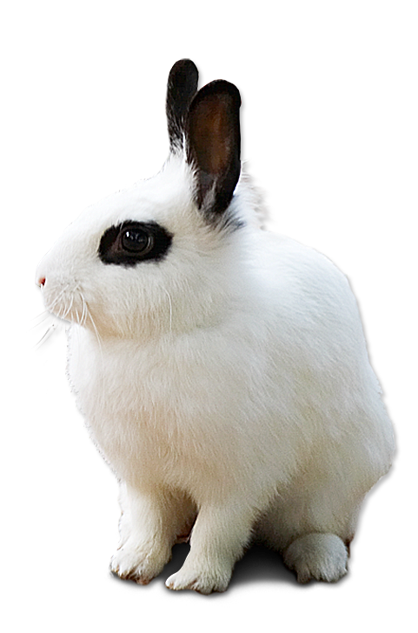
（）8.It is my rabbit.It has long ears. D.
- 选择题
（）1.—___is he?—He is my brother.
A.What B.Who C.Who’s
（）2.—Who’s she?—___is my sister.
A.He B.she C.She
（）3.This is ___grandfather.
A.my B.he C.she
（）4.—___is my father.He is big.
A.She B.He C.It
（）5.Nice___meet you,___.
A.too,to B.to,too C.to,to
（）6.—What ___ she look like?
—She is pretty.
A.do B.does C.is
（）7.—I’m sorry.
—___.
A.That’s OK! B.Me too! C.Welcome!
（）8.She is a ___.She is nice.
A.man B.boy C.woman
- 情景匹配
（）1.Who's she? A.No,she is a woman.
（）2.Is he a boy? B.She is my classmate.
（）3.What’s her name? C.Yes,he is a boy.
（）4.What’s his name? D.His name is Leo.
（）5.Is she a girl? E.Her name is Anita.
- 读句子排序，编成一段通顺的对话
（）Her name is Linda.
（）Look!Who’s the girl?
（）She is my classmate.
（）What’s her name?
- 判断正误，用“√”或“×”表示
（）1.—Who’s he?
—She is my sister，Linda.
（）2.—This is my brother,Jack.
—Hi,Jack.
（）3.What does she look like?她长得什么样？
（）4.She is tall and pretty.她又瘦又漂亮。
（）5.He is ugly.他很丑。
（）6.I have a new classmate.我有一个新朋友。

答案：
一、1.man2.woman3.girl4.boy5.man
二、1-4 AAAA 5-8ADBC
- BCABBBAC
- BCEDA
- 4123
- ×√√×√×

