姓名： 班级： 学号：
人教版小学英语二年级上册期中复习题（A卷）

题号 | 一 | 二 | 三 | 四 | 总分
分数
- 看图连线 （）
- grandfather
- 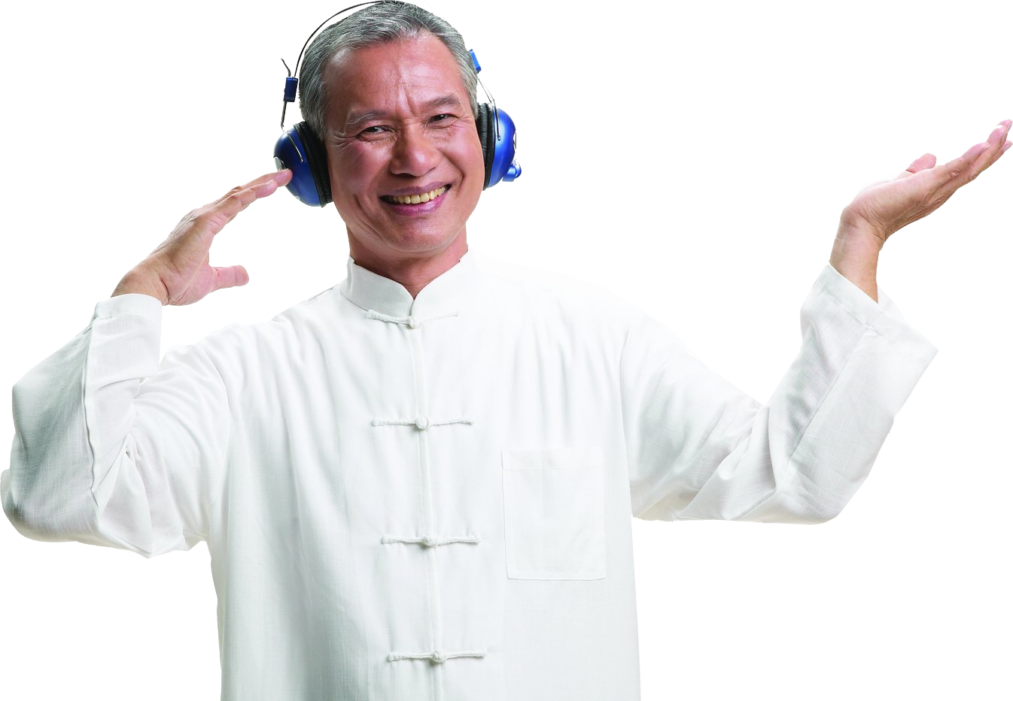 father
- grandmother
4. girl
5. woman
6. head
7. boy
8.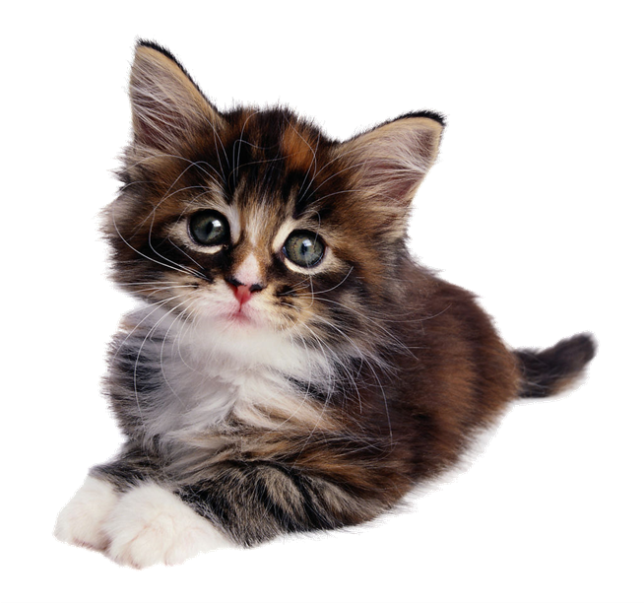 book
9.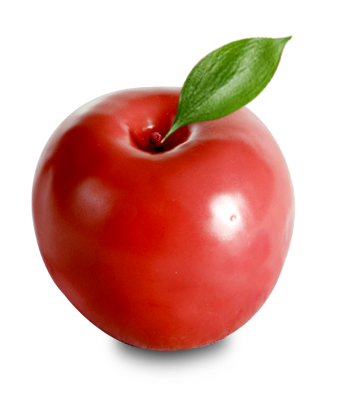 apple
10.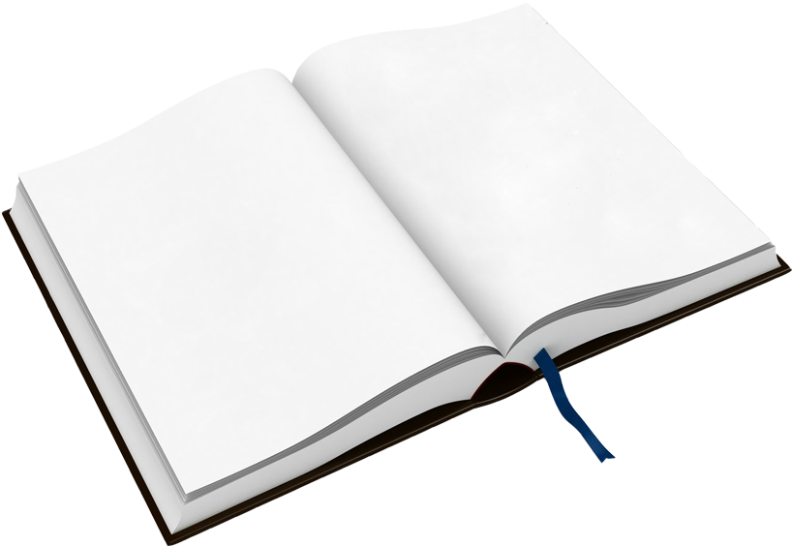 cat
二、看图判断句子正误 （）
1. 2.
She is my mother.( ) This is my grandmother.( )
3. 4.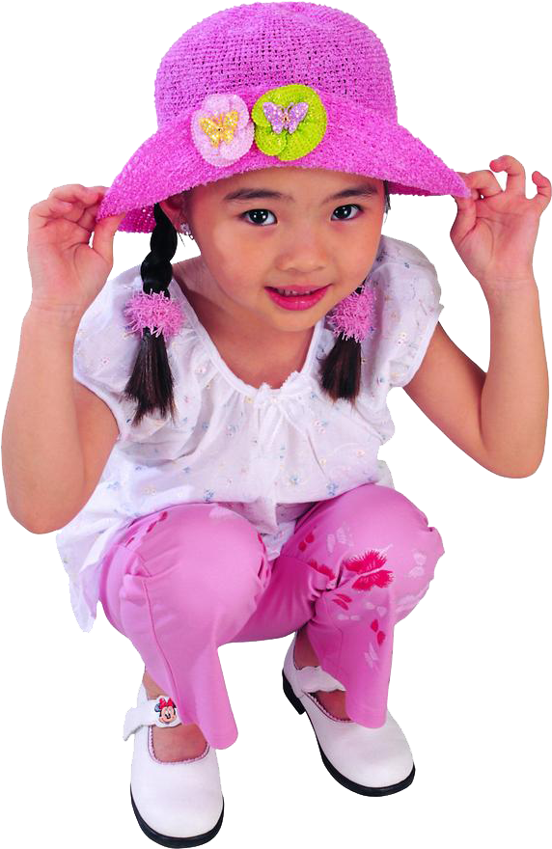
He is big.( ) His name is Lulu.( )
- 6.
Her name is Candy.( ) He is a man.( )
- 情景匹配 （）
（）1.Who’s she? A.Nice to meet you,too.
（）2.Who’s he? B.Nice to meet you,Amy!
（）3.Nice to meet you. C.Hello,Tom!
（）4.This is my sister,Amy. D.She is my grandmother.
（）5.Hi,Mary! E.He is my father.
- 根据提示，圈出正确的单词补全句子 （）
- —(What’s/Who’s) his name?
—(Her/His) name is Wu Peng.
- —Who’s (she/her)?
—She’s my mother.
- —What’s (his/her)name?
—Her name is Amy.
- —Is he a (woman/man)?
—Yes，he is.
- This is my (classmate/friend)（朋友）.
- (His/Her)（他的）name is Steven.
- (She/He)（他）is tall and (big/thin)（瘦的）.
- He is (handsome/pretty)（帅气的）,too.

答案：
一、1.grandmother2.grandfather3.father4.woman5.girl6.boy7.head8.cat9.apple10.book
- × √ × × √ √
- D E A B C
- 1.What’s His 2.she3.her4.man5.friend6.His7.He thin8.handsome

