姓名： 班级： 学号：
人教版小学英语一年级上册期中复习题（B卷）

题号 | 一 | 二 | 三 | 四 | 五 | 总分
分数

- 看图，圈出正确的单词。
1.
h | b | o | o | k | e

2.
x | z | p | e | n | c | i | l

3.
t | h | m | o | u | t | h | e

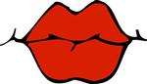
4.
t | x | m | o | n | k | e | y | o | q

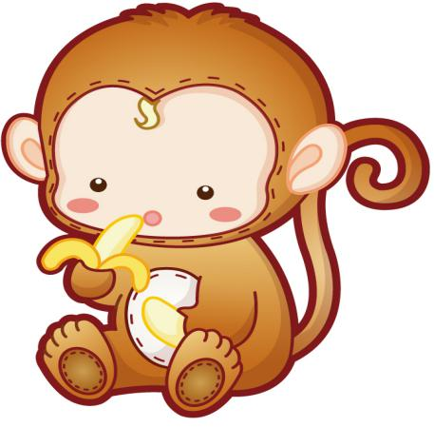
5.
p | t | i | g | e | r | h | o | d | e

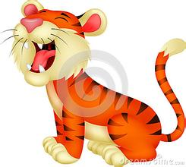
- 判断下列图片与句子是否匹配，用“√ ” 或“×”表示。

- Open your schoolbag. ( )
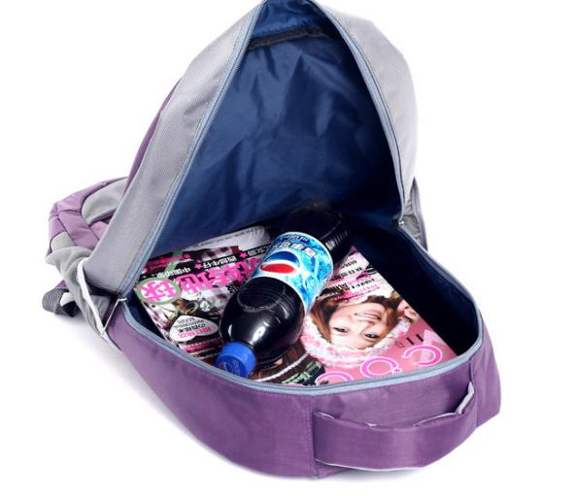
- This is my school. ( )
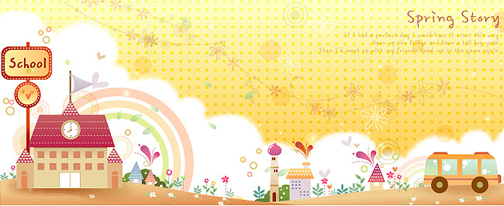
- I have no tail. ( ）
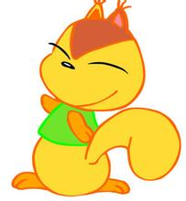

- Act like a bird. ( ）
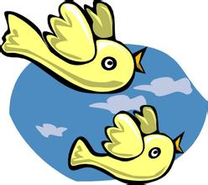
- It is a monkey. ( )
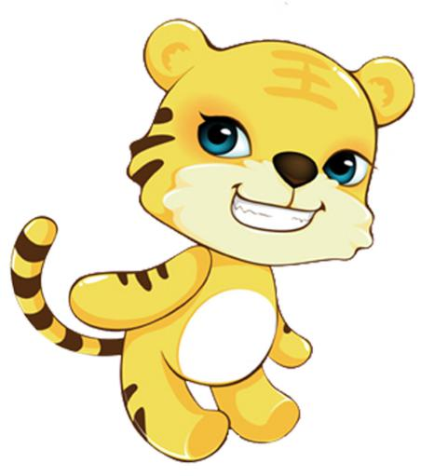
三、情景匹配。
( ) 1.Touch your nose. A. I am Bill.
( ) 2.I have a mouth. B. OK.
( ) 3.Good morning. C.Me,too.
( ) 4.What is your name? D.Good morning.
( ) 5.Goodbye. E.Goodbye.
- 情景选择。
( ) 1.早晨见到老师，你应该说：
- Good morning. B.Goodbye.
（ ) 2.告诉别人，你有一个东西，可以说：
A.Show me your... B.I have a...
( ) 3.请别人打开书，你可以说：
A. Close your book. B. Open your book.
( ) 4.问别人这是什么，可以说：
A. What is this? B.It is a dog.
( ) 5.想告诉别人这是一把尺，可以说：
A. It is a ruler. B.I have a ruler.
- 把下列句子译成中文。
- Bye-bye.

- I have a monkey.

- Act like a cat.

- What is this?

参考答案
- book pencil mouth monkey tiger
- √ √ × √ √
- B C D A E
- A B B A A
- 1.再见。
2.我有一只猴子。
3.像猫一样表演。
4.这是什么？

