姓名： 班级： 学号：
人教版小学英语一年级上册期中复习题（A卷）

题号 | 一 | 二 | 三 | 四 | 总分
分数

- 看图连线
- ruler
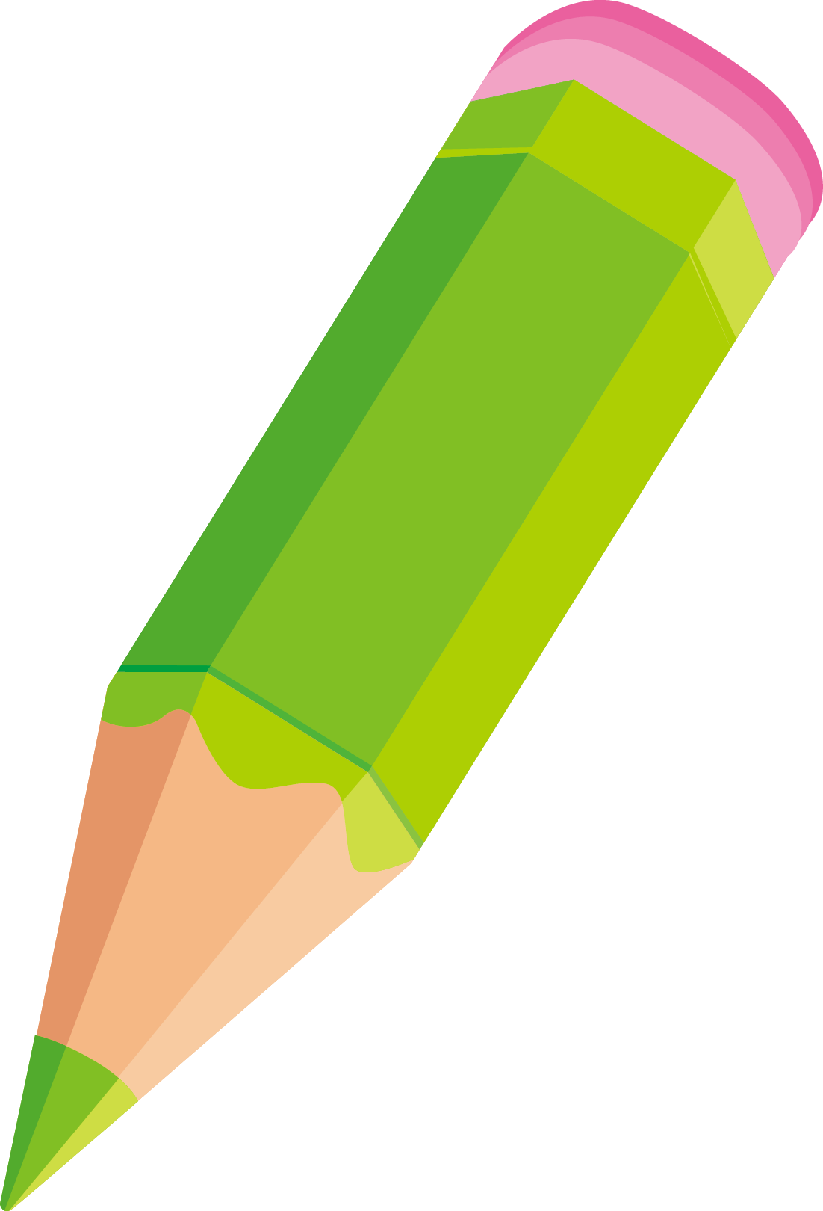
- ear
3. dog
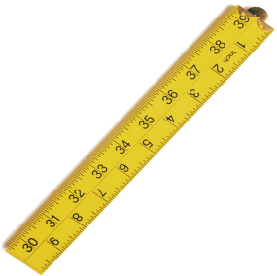

4. book
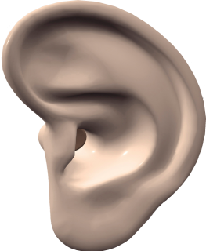

5. pencil
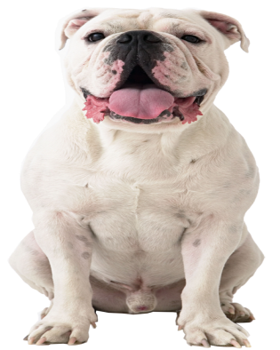

- 为下列图片选择相应的句子，圈出序号
1. A. Stand up. B.Sit down.
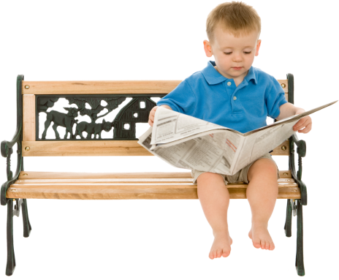

2. A. Open your mouth. B. Close your mouth.
3. A. This is a tiger. B. This is a cat.
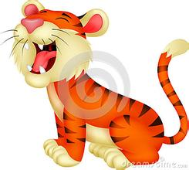
4. A. I have a dog. B. I have a book.
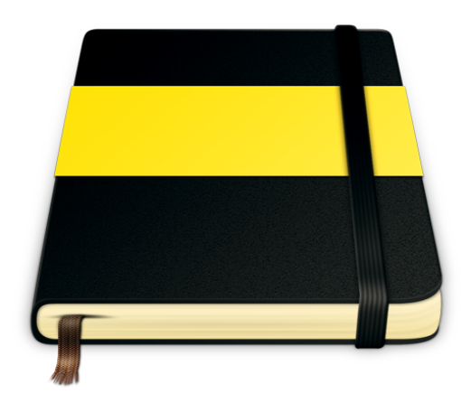
5. A. I have a book. B. I have a schoolbag.
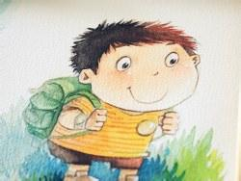
- 情景匹配
( ) 1. Close your book. A. Good night.
( ) 2. Good morning. B. OK.
( ) 3. What’s missing? C.Wow.
( ) 4. Good night. D. Good morning.
( ) 5. I have a schoolbag. E. A pencil.
四、判断句子的译文是否正确，用“√ ” 或“×”表示。
（ ）1. Touch your eyes. 这是我的眼睛。
（ ） 2. I have no tail. 我没有尾巴。
（ ） 3. What is this? 这是什么？
（ ）4. Show me your cat. 我有一只猫。
（ ）5. It is a bird. 这是一只熊。

参考答案
- pencil book ruler ear dog
- B B A B B
- B D E A C
- × √ √ × ×

