姓名： 班级： 学号：
牛津版小学英语三年级上期中复习试卷

题号 | 一 | 二 | 三 | 四 | 五 | 六 | 七 | 八 | 总分
分数
一、写出下列字母的左邻右舍（10%）
1、（ ）Pp（ ） 2、（ ）Uu（ ） 3、（ ）Hh（ ）
4、（ ）Dd（ ） 5、（ ）Jj （ ）
二．将下列图片和所给单词配对，填单词前的序号（20%）
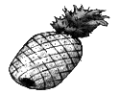
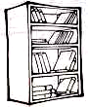
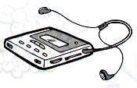
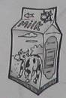
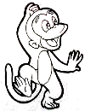

（ ） （ ） （ ） （ ） （ ）
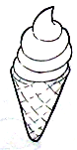
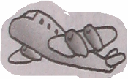
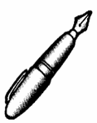
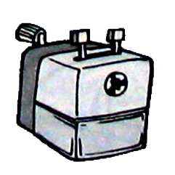
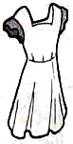

（ ） （ ） （ ） （ ） （ ）

A. pen B. milk C. pineapple D. pencil-sharpner E. dress
F. plane G. bookcase H. ice-cream I. monkey J. walkman
三．六，选出不同类。（20分）
( ) 1.A. desk B. table C. seven
( ) 2. A. sister B. dress C. baby
( ) 3. A. hot dog B. shy C. sun
( ) 4 .A. five B. eight C. slide
( ) 5. A. fly B. two C. hen
( ) 6. A. star B. circle C. cake
( ) 7.A. apple B. banana C. book
( ) 8.A. pencil B. box C. butterfly
( ) 9, A, swing B, slide C, tree
( ) 10,A, mouse B, pig C, bee
四．看图填单词。（10分）

___ ice cream ______ orange
two _______ five _______

three _______ four _______

五．从B栏中找出A栏的应答语.(10分)
A B
( )1. Good afternoon . A. Yes , he is .
( )2. Eight cakes , please . B. She’s my sister .
( )3. Is he your little brother ? C. They are pigs.
( )4. Who’s she ? D. Good afternoon .
( )5. What are they ? E. Here you are .

六、选择填空（30%）
（ ）1. This is my , Mr Li..
A. sister B. mother C. brother
（ ）2. Hello, what’s your ?
A. nice B. name C. this
（ ）3. Go to , now. Good night.
A. school B. home C. bed
（ ）4. are you , Mrs Black?
A. And B. Good C. How
（ ）5. Nancy Black is English girl.
A. a B. an C. /
（ ）6. Here’s my orange.
A. a B. an C. /
（ ）7. This is my mother , Li.
A . Mr B. Mrs C. Miss
（ ）8. to meet you .
A. Glad B. How C. What
（ ）9. What can you see ? I can see some
A. peach B. peachs C. peaches
（ ）10. — Let’s go to Xi’an.
— Great, ?
— By plane.
A. how B. how about C. but how
（ ）11. a new T-shirt.
A. That’s B. This C. That
（ ）12. — ________ his shirt. — It’s smart.
A. Look B. See C. Look at
（ ）13. This is a coat. It’s .
A. tall B. big C. Thank you
（ ）14. — I’m cold(冷的). , please.
— Ok.
A. Open the door B. close the door C. Turn on the door
（ ）15. My father is a man.
A. short B. long C.pretty
七.填空。（10分）
late rain old clean grandfather

1. My father’s father is my_________________.
2.____________ your desk, please.
3. You are very _____________.
4. My sister is 11 years ____________.
5. Two tall teachers in the _____________.
八，阅读理解.（10分）
判断下面句子的意思是否与短文内容相符，对的写T， 错的写F.
This is my school , It’s big and beautiful , There are two playgrounds in my school , Look , that is my classroom. We sing and dance in our classroom . This is the library . It isn’t big . But we can read many books in the library . I’m happy in the school , I love my school .
( )1. My school has two playgrounds .
( )2. My classroom is big .
( )3. The library is big .
( )4. We sing and dance on the playground .
( )5. There are(有) many books in the library .

参考答案
一．1. Oo Qq 2.Tt Vv 3.Gg Ii 4.Cc Ee 5.Ii Kk
二．CGJBIFAHDE
三．CBBCB CCCCC
四．1. one 2.an 3.babys 4.candies 5.chairs 6.pears
五．DEABC
六．CBCCB CBACC ACBBC
七．1. grandfather 2.clean 3.late 4.old 5.rain
八．TFFFT

