姓名： 班级： 学号：

牛津版二年级上期中复习试卷

|  |  |  |  |  |  |  |  |  |  |
| --- | --- | --- | --- | --- | --- | --- | --- | --- | --- |
| 题号 | 一 | 二 | 三 | 四 | 五 | 六 | 七 | 八 | 总分 |
| 分数 |  |  |  |  |  |  |  |  |  |

一 ．读单词，圈出不同类的词。

1. panda horse bird bear

2. skip climb fly bed

3. ferry plane train car

4. lamp vain bed table

5. duck sleep pig elephant

**二. Letters (字母) 10%**

**左右邻居：**

1. ____r___ 2. ___ l___ 3. ___o ___ 4. ___d ___ 5. ___ x___

三.[读单词](http://www.qeto.com/bag/show_ftag/569-0-0-1)，在相应图片的方框内写上序号。

cow sofa walk rabbit umbrella

 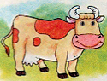 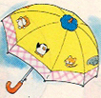

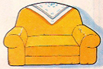 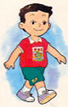

**四. Write (正确抄写单词和句子) 5%**

1. How are you? Fine, thank you.

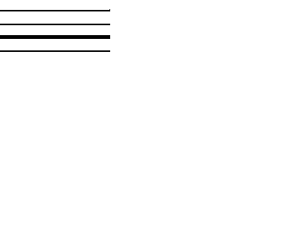

2. Fine, thank you.



3. Don’t ride a bicycle here.



4. Spotty! Come here.



五．读上句，圈下句, 在正确句子前面的括号里打√ 。

1. What can Spotty do? ( ) Spotty can run. ( ) I can run.

2. What do you see? ( ) I see a duck. ( ) I hear a duck.

3. How are you? ( ) Thank you. ( ) Fine, thank you.

4. Do you like winter? ( ) Yes, I don’t. ( ) No, I don’t.

5. Where do you live? ( ) I live in Shiyan. ( ) I love Shiyan.

**六. Choice (选择) 10%**

( ) 1. __________ are you, Alice? I’m fine. Thank you.

A. Who B. How

( ) 2. You’re big. No. I’m __________.

A. small B. young

( ) 3. This is my grandmother. She’s __________.

A. old B. young

( ) 4. My nose __________ small.

A. is B. are

( ) 5. What can you do? __________

A. Yes, I can. B. I can swim.

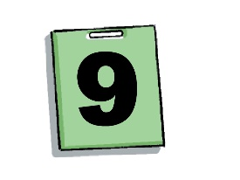**七. Write the proper words (看图片，写单词) 10%**

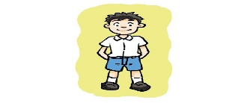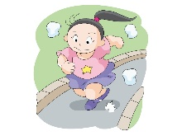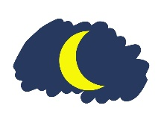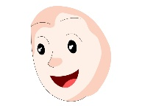

1． Can Supergirl _________? Yes, she can.

2. How many bags do you see? I see ________.

3. My ________ is round.

4. Good ____________.

5. The boy is ________.

**八. Read and judge （阅读文章，判断，用T或F表示） 10%**

Hello, I’m Giant. I’m big. I’m tall. My head is big. My eyes are big and my mouth is big, too. My nose is short. My hair is short, too. I like apples.

This is Supergirl. She is small. She is short. She can run, swim and fly. But she can’t write. Look, the face is round. The eyes are big. The hair is long. I like Supergirl, too.

( ) 1. Giant is not short.

( ) 2. Giant’s（的） nose is small.

( ) 3. Giant’s （的）mouth is big.

( ) 4. Supergirl’s （的）face is round.

( ) 5. She can write.

英语参考答案

一．1. bird 2.bed 3.ferry 4.vain 5.elephant

二．1. qs 2.wn 3.np 4.ce 5.wy

三． 41523

四．应正确的规范书写则可

五．1 1 2 2 1

六．BAAAB

七．1. run 2.9 3.face/head 4.night 5.strong

八．TFTTF